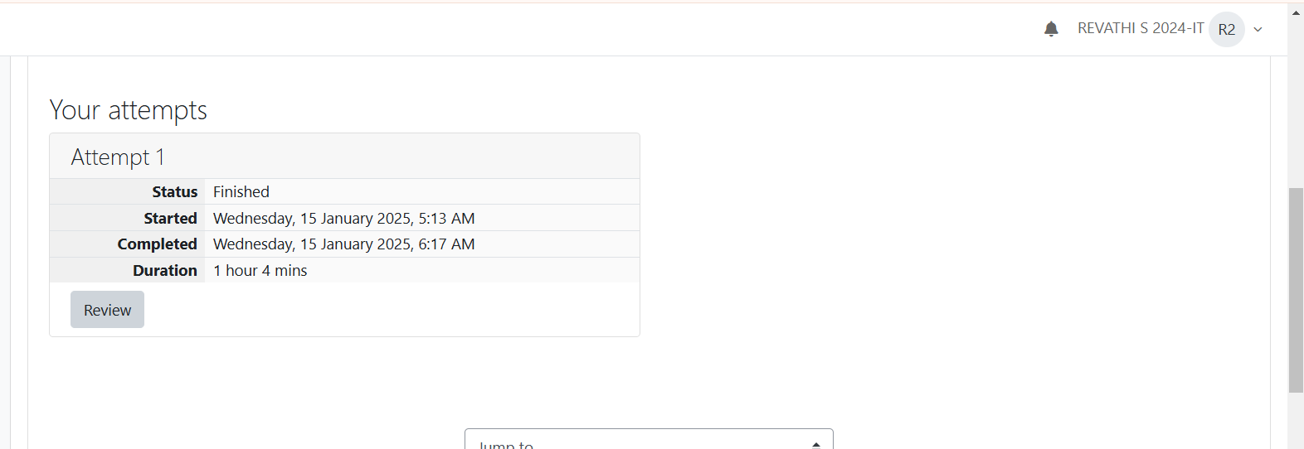

You are given a two-dimensional 3*3 array starting from A [0][0]. You should add the alternate elements of the array and print its sum. It should print two different numbers the first being sum of A 0 0, A 0 2, A 1 1, A 2 0, A 2 2 and A 0 1, A 1 0, A 1 2, A 2 1.

**Input Format**

First and only line contains the value of array separated by single space.

**Output Format**

First line should print sum of A 0 0, A 0 2, A 1 1, A 2 0, A 2 2

Second line should print sum of A 0 1, A 1 0, A 1 2, A 2 1

**SAMPLE INPUT**

1 2 3 4 5 6 7 8 9

**SAMPLE OUTPUT**

25

20

Microsoft has come to hire interns from your college. N students got shortlisted out of which few were males and a few females. All the students have been assigned talent levels. Smaller the talent level, lesser is your chance to be selected. Microsoft wants to create the result list where it wants the candidates sorted according to their talent levels, but there is a catch. This time Microsoft wants to hire female candidates first and then male candidates.

The task is to create a list where first all-female candidates are sorted in a descending order and then male candidates are sorted in a descending order.

Input Format

The first line contains an integer N denoting the number of students. Next, N lines contain two space-separated integers, ai and bi.

The first integer, ai will be either 1(for a male candidate) or 0(for female candidate).

The second integer, bi will be the candidate's talent level.

Constraints

***1 <= N <= 105***

***0 <= ai <= 1***

***1 <= bi <= 109***

Output Format

Output   space-separated integers, which first contains the talent levels of all female candidates sorted in descending order and then the talent levels of male candidates in descending order.

SAMPLE INPUT

5

0 3

1 6

0 2

0 7

1 15

SAMPLE OUTPUT

7 3 2 15 6

